# Programmer’s Guide

# Section 1: Assumptions about the Programmer

The programmer's system must have Python and Pygame installed, and they should use PyCharm or another Python integrated development environment to maintain their code up to date. This application, which was written in Python, is compatible with a wide range of operating systems. The code was written in the PyCharm environment and subsequently exchanged and preserved on the GitHub platform. All of the pictures and audio are included in the folder and can be used in any way you want without any limitations. The results will be saved in a txt file that has already been specified in the folder for easy retrieval at a later time. Using the information in the txt file, we will be able to calculate the average, shortest run time, and longest run duration, among other things. When the information is collected, students can review it to see how variables such as the number of players and the size of the maps influence the information and the time required to process it.

# Section 2: High Level Design

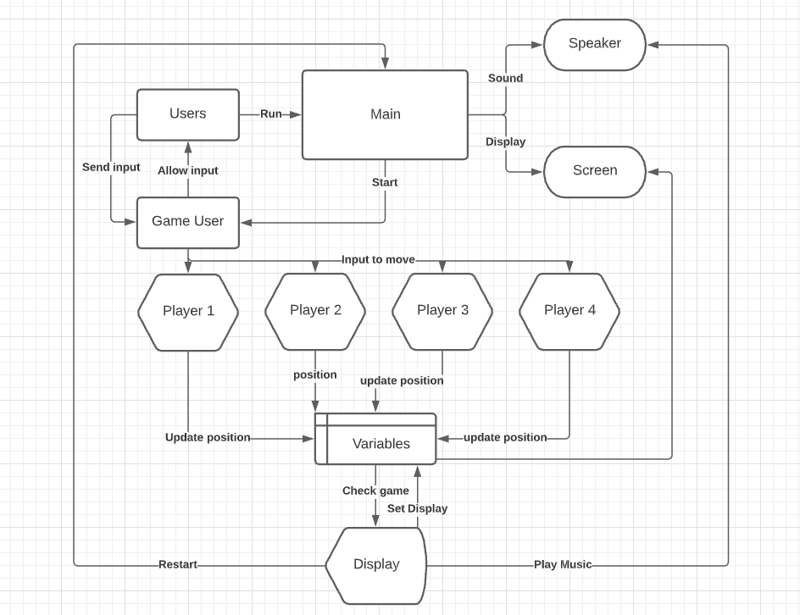

**Section 3: More Detailed Designs**

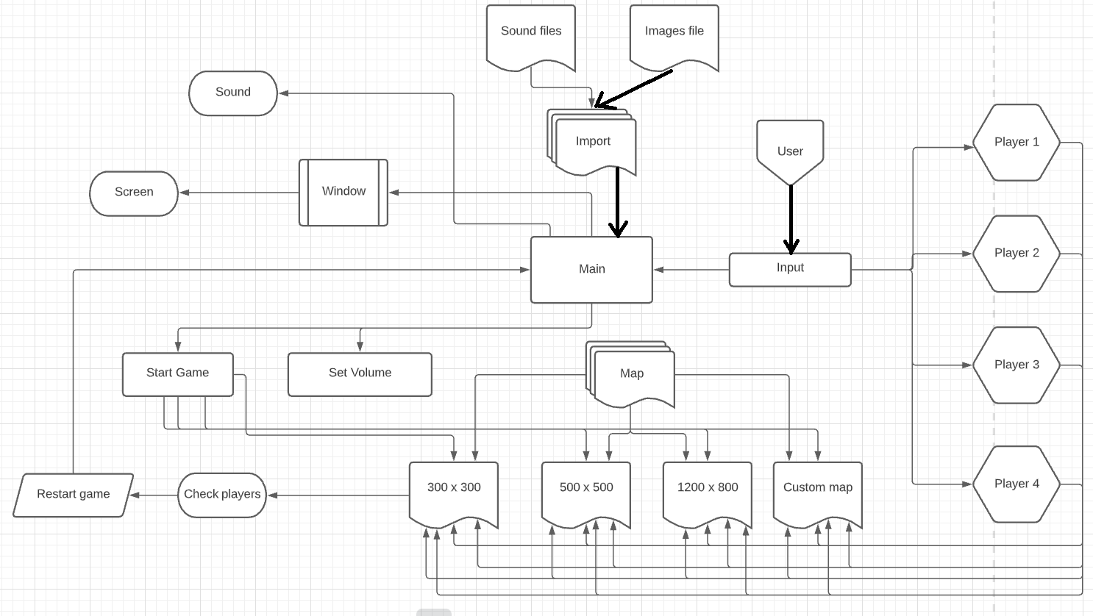

# Section 4: Installation Instructions

The installation instructions are clear and easy to follow, even for those with little prior technical knowledge.

To download and run the application, follow these steps:

The first step is to obtain Python and install it on your PC. To do this,

go to https://www.python.org/ and click the link.

Select your computer's operating system from the download tab.

If it says "Python 3.9.5", then you'll want to use that version. This will begin the download process for you.

After that, simply adhere to the installation instructions that appear on screen.

You will be given the opportunity to add Python to the PATH for Windows devices. To use this option, simply choose it by clicking the box in front of it.

To play this game, you'll first need to download and install the following library: open a command prompt and execute the following commands: For Windows, use the following commands: to install pygame, run the following command in the shell:

In order to install Pygame, run the following command in your terminal window.

Now that the src folder has been unzipped, you may open the zip file and begin working in it.

Start the game by typing "python menu.py" at the command prompt.

To analyze numerous saved games, use the command "python analyze.py".

This is a step-by-step guide on how to download and set up the software required to run the program and then the game itself. In order to navigate the menu and select different game modes, please refer to the user manual provided with your game.

**Appendix A: Implementation Code Menu.py:**

There are universal functions for updating the player's x and y coordinates that can be used by all game modes, including player1, player2, player3, and player4. A drawing function is available as well, and it may be used to show the player and map image in real-time. The movement function includes collision detection methods that are invoked when a player runs into a wall. The function record () is called at the end of each stimulation to save the stimulation data in a text file for further study. With so many different ways to play the map, it's easy to become lost.

**Analyze.py:**

The average, longest, and shortest paths are determined using a function called data sorter and the step data listed in the.txt file in the results folder. An analysis of stimulation data is available, as well as an analysis of user manual input data. The data is organized and presented in a logical manner.

**Appendix B:** Read the User Manual

**Appendix C:** Read the Test Plans